Gabrielle Ross
February 12, 2013
GCP Research Paper
Infanticide and Feticide of Girls in China
The infanticide and feticide of girls is a problem that largely goes unnoticed around the world, especially in developing countries like India and China. Due to a variety of reasons, girls, both before and after birth, are being killed because they are less desirable than boys. In China, throughout history their culture has dictated that women are inferior to men. Although China is modernizing and this social norm is changing, in many parts of rural China this belief is still held. Boys are also thought to be more profitable than girls, so if a family lives in poverty, they believe a boy could help them more than a girl. Furthermore, the One-Child Policy stating a family in China can only have one child puts more pressure on parents to have a son rather than a daughter. The preference for sons has caused the male to female ratio at birth in China to be 113 boys for every 100 girls in 2011 (CIA World Fact Book). Chai Ling, a Nobel Prize nominee and former top Tiananmen Square student leader, said, “Let's pray for the 35,000 babies a day in China who are not allowed to live, and for their parents, whose choices are unthinkably difficult in the midst of great pressure”, this pressure being social, economic, and political. Many girls in China are not getting a chance, and very little is being done about it. Culture, poverty, and the One-Child Policy have contributed to female infanticide and feticide in China.
Infanticide is defined as the crime of killing an unwanted child less than one year of age, especially by its own parent(s). It is the intentional killing of an infant, either by murder, neglect or abandonment, or malnutrition. Feticide is defined as the destruction of an unborn child, or fetus, but this paper will focus only on gender-selective abortions. Parents also get rid of female children by trafficking them. All together, this systematic elimination of girls is called gendercide. Every year, more girls are victims of gendercide in China and India than the number of girls born in America. The United Nations Development Program issued a report in 2010 stating, “Asia has the highest male-female sex ratio at birth in the world, with sex-selective abortion and infanticide leaving a trail of 96 million ‘missing’ women in some countries”.
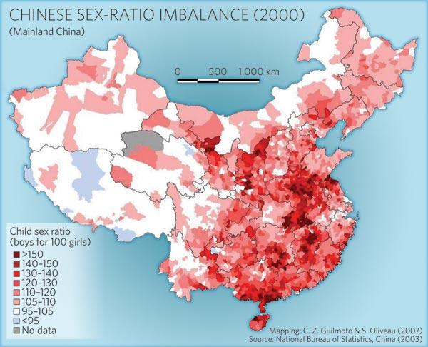
Preference for sons is a part of Chinese culture that has lasted for centuries. This is especially prevalent in rural China, but has still not yet completely disappeared in more modern cities. High value is placed on having male children; in ancient China a woman’s only job was to give birth to sons and she was considered useless if she could not, and still today there is a strong partiality for boys. Confucian teachings created this, making men the head of society and the family. In ancient Chinese culture, women were inferior to men; they were expected only to be obedient, with their place in the household. This was reinforced by the practice of foot binding, an extremely painful practice to keep their feet tiny, crippling them for life just to make them more desirable wives. Cara Abraham wrote:
The status of women was set at birth. Sons were cherished additions to a family, not only for their physical and economic ability to contribute to the family, but also as the carrier of the family name. Only a son could provide for his elderly parents and properly venerate his ancestors… In times of famine or dangerous warfare, daughters were the last to be fed, and newborn girls were smothered. While such severe actions were rare, they did occur and left a lasting legacy of discrimination against females. (Women’s Roles in China)
Later in revolutionary China, women were given more rights, but were still far from equal. With the creation of the One Child Policy, which will be discussed further later, this ongoing preference for boys truly showed. Furthermore, in the 1970’s with the invention of ultrasound, it was now possible to determine the sex of a fetus, making it easier for gendercide to occur, especially in a society that already had such a strong inclination toward sons. For a country with such a rich culture, it is hard to escape traditional values. In a report from The Economist it explained:
For millions of couples, the answer is: abort the daughter, try for a son. In China and northern India more than 120 boys are being born for every 100 girls. Nature dictates that slightly more males are born than females to offset boys' greater susceptibility to infant disease. But nothing on this scale.
In some rural parts of China, where the culture is stronger and less diluted by westernization, the ratio is even as high as 150 boys for every 100 girls. There is very little gender imbalance in regions like Tibet and areas near Mongolia where the culture is very different, which shows just how much the beliefs of a society play a role. With the preference for boys already being a dangerous factor, the absence of traditional values against abortion or abandonment of female children creates an incredibly high risk for widespread gendercide. Despite being very patriarchal, normal sex ratios have been found for Christians and Muslims since their religions strictly forbid infanticide. During the Cultural Revolution starting in 1966, religion was outlawed, and since then has not seen much of a revival, although there is now religious freedom. The percentage of people in China who define themselves as religious is one of the lowest in the world (although their cultural practices could be considered a religion), and their culture does not dictate that forms of gendercide are unacceptable either. This is not to say that they do these things easily, many are desperate and feel they have no other option and some women are forced to give up their daughters, but the preference for male children has been so pervasive in the past that these seemingly unthinkable actions have become tolerable within Chinese society.
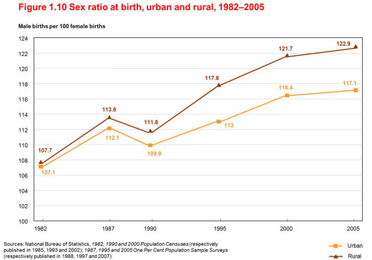
China, although growing rapidly, is still a developing country with wealth concentrated mostly in cities, while many in more rural regions remain in poverty. This poverty and wealth disparity adds an economic incentive to have boys onto the cultural preference. Historically the major burden girls put on families was the expensive dowry the family would have to pay when daughters married. Also, not just in China, but all over the world, women have traditionally been responsible for the household rather than the family income. This has been changing, but economic opportunity for women is not yet completely equal, making boys more desirable for families that are having trouble getting by. Women have less access to education and are paid less than men in the same professions. In rural areas where physical labor is needed, having a boy is also seen as more advantageous. Both women and men are now leaving to find jobs and become migrant workers in Chinese cities, but men are far more successful. According to the Ministry of Labour and Social Security in 2002, women’s wages were between 88.5% and 74.5% of men’s wages in the same sectors. Author Jing Lin wrote:
…after more than 25 years of economic reform, rural women have become a diverse group: A small number have become successful owning their own businesses; some have settled down in cities and become integrated into urban life, while the majority of others are still working at the margin of cities… job opportunities given to them are mostly low skill, low paid, low social status jobs.
Many work long hours with a low salary and low job security. Because of economic discrimination against females, males are more profitable, and thus are more desired by couples who can only have one child due to the One Child Policy. It is also normal in Chinese society for children to take care of their parents in old age because there is no Social Security. This means having the parents live with them and providing for them financially. If parents believe only a son would be able to take on that economic burden, or simply that they would be better taken care of by a son because he would be more successful, then couples will make sure they have a boy rather than a girl. Just the belief that sons will contribute more makes girls less wanted. An old Tibetan proverb states, “Daughters are no better than crows. Their parents feed them and when they get their wings, they fly away”. However, many disagree with the idea that poverty is one of the main factors driving gendercide. The Economist states, “Wealth does not stop it. Taiwan and Singapore have open, rich economies. Within China and India the areas with the worst sex ratios are the richest, best-educated ones”. An article in The Independent testifies that “Wealthier, better-educated couples are the worst offenders, the findings show, [ending] hopes that socio-economic progress would lead to a change in attitude…Better-off families have access to and can afford the ultrasound tests to reveal the sex of a fetus”. Whether sex ratios are worse in cities or rural parts of China is hard to decipher, as statistical data varies significantly. The World Bank report states that both “a higher SRB (Sex Ratios at Birth) has no direct correlation with levels of economic development” and that “SRBs in poverty-stricken areas are considerably higher than the normal range”, showing how contradictory the data can be. Furthermore, pre-natal sex determination tests have not been proven more prevalent in cities or rural China; information on that also varies. Edgar Dahl writes in “Gendercide? A Commentary on The Economist’s Report about the Worldwide War on Baby Girls” that The Economist “underestimates the economic logic behind the son preference”. The argument that the wealthy are more to blame for gendercide in China is inaccurate as well; poor couples may not be able to afford an ultrasound and thus will not have an abortion, but may abandon or kill the baby post-birth. Additionally, it is illegal to take a sex determination test, but is much easier to illegally conduct them in rural areas. So although it may not be the only cause of gendercide, poverty causes many Chinese couples to choose to keep trying for a boy because financially he has better chances.
The One-Child Policy, more accurately translated as the Family Planning Policy, started in 1979 to help alleviate social, economic, and environmental problems partially caused by a rapidly growing population. The policy does not actually apply to the entire population, as many foreigners believe; in reality only about 35% of the population is affected by it. The Family Planning Policy states that married, urban, and ethnically Han couples who both have siblings can only have one child without a serious fine and the possible loss of their job, housing, or other benefits. Exceptions include ethnic minorities and couples who are both the only children in their family. Rural couples are able to have a second child if their first child is a girl, and all couples are allowed to have a second child if they have twins, their first child dies, or their first child is seriously disabled. The policy does not apply at all to the regions of Hong Kong or Macau. It has been incredibly successful in reducing population growth and since it started has been estimated to have reduced the population by at least 250 million, with some estimates as high as 300 million, which is equivalent to the population of Europe. However, this has come at a great cost to Chinese citizens, especially when it comes to women’s rights, and is a major factor in China’s sex imbalance. Despite this, the One-Child Policy had a 76% approval rating in 2008. The role the policy has in the gender discrepancy is hardly argued, as the greatest changes in the sex-ratios began in the early 1980’s, right after the One-Child Policy began to take effect. According to the organization All Girls Allowed, “Since the policy began, 37 million Chinese girls have been lost. That’s more than the number of people killed in all the major genocides of the past century combined.” With the pressure to have a son even greater since many couples have only one opportunity, more and more girls have been selectively aborted. There have also been many accounts of other family members forcing expectant mothers to abort against their will if they knew the child was a female. Margaret Wente of Canada’s The Globe and Mail wrote, “…it's ironic that the hard-won right of women to control their reproductive futures has become a weapon for the ultimate discrimination against girls.” Also starting in 1980, the ratio of females to males given to orphanages skyrocketed and today two thirds of children given up for adoption in China are girls. Many orphanages do not have the resources they need, and the care the children receive is in some cases seriously inadequate. In some orphanages in rural China, they have what is called a “dying room” where girls they cannot take care of are left to perish. According to the Los Angeles Times though, many babies were not willingly put up for adoption, but confiscated by government officials. Female children can also sometimes go unregistered if the parents want to try again for a son, leaving them unable to receive an education or healthcare. Other repercussions are increased kidnappings of baby boys to couples that continue to have girls. There have also been numerous reports of brutal or botched forced abortions and sterilizations by the government, even as late as 9 months into pregnancy. With social and economic pressures already putting baby girls at risk, the One-Child Policy only makes matters worse and adds to the discrimination against females, putting population control before the lives of the country’s girls.
The imbalanced sex-ratio in favor of males is not only a reflection of the reduced value girls’ lives have in China, but is also the cause of countless other problems their society now faces, most of which continue to negatively affect females more than males. With less women, a growing number of men are finding it difficult to find a wife and are turning to human trafficking to buy one. More and more girls from surrounding countries are being captured and trafficked into China or coerced with false promises of a job to meet the demand for women. Although human trafficking has increased in almost all parts of the world, the excess of males seems to be the cause for China:
Experts and NGOs report that China’s population planning policies, coupled with a cultural preference for sons, creates a skewed sex ratio in China, which may contribute to the trafficking of women and children from within China and from Mongolia, North Korea, Russia, Burma, Laos, and Vietnam for forced marriage. The Chinese Academy of Social Sciences estimated that by 2020, there could be as many as 24 million more men than women of marriageable age (ages 19-45) in China, exacerbating the problem. (humantrafficking.org)
Bride abduction, or marriage through kidnapping, although normally only thought of as in the Middle East, has now spread to China, and the country has seen a huge increase in sex slavery and prostitution although illegal. Since 1982, around the time the One-Child Policy began, China has seen an increase in prostitution every year, and thus has also seen a resurgence of sexually transmitted diseases. The crime rate has also nearly doubled since 1988, and a study conducted by Lena Edlund at Columbia University says that for every 1% increase in the ratio between males and females, there is up to a 6% increase in violent and property crimes. China also has one of the highest suicide rates for women in their reproductive years in the world, many pointing to the guilt young mothers may feel after aborting or killing a daughter.
Recently this issue has received more attention and gradually the world is beginning to acknowledge the idea of gendercide. Despite the increased awareness and effort though, there has not been much progress in China when it comes to lessening infanticide and feticide. The government made it illegal to have a sex-determination test in 1994, but this has done little, as rich families can bribe doctors, the law is hardly enforced in rural areas, illegal ultrasound clinics can be found around the country, and daughters can still be killed or abandoned post-birth. Despite the One-Child Policy being partially responsible for this problem, the exception allowing rural couples to have a second child if their first is a girl, although seemingly discriminatory against baby girls, was actually created to save their lives and to some extent it has. Further, the government has tried to use propaganda to encourage couples to want to keep their daughters, but it is difficult to know if this has had any impact. Numerous nongovernmental organizations have sprung up as well such as Women’s Rights without Frontiers, All Girls Allowed, and Stop Gendercide. The main method used to stop gendercide is to essentially pay mothers for a certain amount of time to keep their daughters so that they are no longer seen as an economic burden. Once the family and daughter have had enough time to bond, the risk of infanticide becomes much lower. Any forms of empowerment for women, especially education, job training, and micro-loans, also help to decrease gendercide, as the greater value they have in their communities the less preference there will be for boys.
Gendercide, although more subtle than genocide, is just as, if not more, horrific and damaging to society. With hundreds of years of discrimination against women, the preference for sons will not go away overnight. Also, as long as it is economically beneficial to have a boy, the One-Child Policy will only further encourage families to get rid of their girls. Drastic changes need to be made in order to stop the feticide and infanticide of females in China, not only to save innocent lives, but to also fix other issues caused by the sex-ratio discrepancy. If measures are not taken to alter the cultural perspective on gender roles, eradicate poverty, close the gender wage gap, enforce existing laws, or reform or remove the One-Child Policy, this situation will continue and the number of “missing girls” will only rise.

